**How to run these tests:**

**Please Note I don’t have a mac so I don’t know if the drivers in the project work.**

**The project was tested in windows**

Download the project from here:

<https://github.com/hmir992/cucumberFramework>

* git clone
* Import into eclipse IDE
* Download the correct Windows or Mac Driver and paste it into the folder
* /ryanairCucumberFramework/src/test/resources/drivers

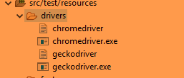

Download the drivers here:

<https://github.com/mozilla/geckodriver/releases/tag/v0.28.0> for FireFox

<https://chromedriver.chromium.org/home> for chrome

After that just go to project root in cmd or terminal:

To run the tests with cucumber jvm report

mvn clean

mvn clean test

mvn verify

/ryanairCucumberFramework/target/cucumber-reports/advanced-reports/cucumber-html-reports/ to see the generated cucumber report

Allure reports can be generated by the following:

mvn clean

mvn clean test

mvn site

mvn jetty:run

Go to <http://localhost:8080/> to see the allure report

**Sample Reporting:**

**Cucumber jvm**

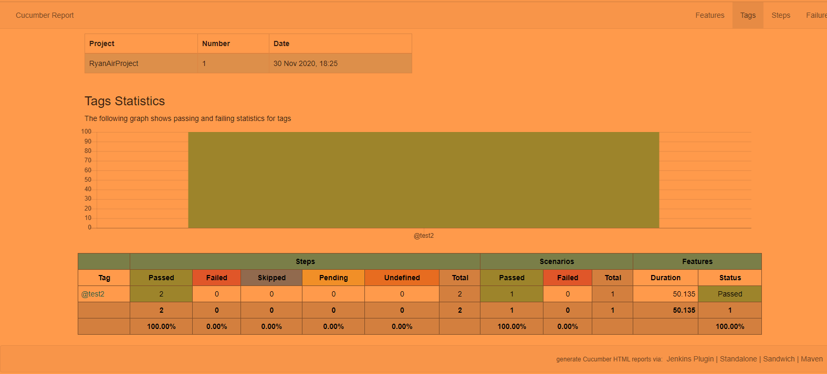

**Allure report:**

